**Nuclear Cardiology Database Project**

Jose Reyes

2019-1002 IST659

**Part 1**

**Intro**

A nuclear stress test is a noninvasive imaging technique in assessing blood flow to diagnose heart disease and guide treatment of disorders. During the test, a radioactive tracer is injected into the patient which can then be detected by a special camera to produce images of the heart. The test usually involves taking two sets of images: one set while the patient is stressed (either through exercise or a pharmacologic agent) and while at rest after exertion.

After a hospital or outpatient center completes a nuclear stress test, the patient and procedure information is recorded in a medical report which is then sent to a clinical data registry for analysis.

In this project, a database will be designed for a clinical data registry, which collects and stores study data. This database will focus on the collection of nuclear stress report data which can then be used to answer specific questions with the goal of improving the quality of health care in cardiology.

**Business rules:**

* Hospital/Outpatient Center enrolls for the clinical data registry
* Hospital/Outpatient Center completes their profile information including site name, address, and physician names and NPI
* Hospital/Outpatient Center performs a nuclear stress test on patient
* Hospital/Outpatient Center records stress test details on a medical report
* Medical report is submitted to a clinical data registry

This data is useful to several stakeholders including health practices who want to determine what areas of nuclear cardiology need improvement. This is also of interest to health insurance and other payors who are interested in knowing the rate of appropriate and inappropriate testing. Finally, and most importantly, it is important for patient health and treatment. Nuclear cardiology includes levels of radiation, risk, and adverse effects, and maintaining a high quality in this practice is important in the cardiovascular field to make safe and proper diagnoses.

**Conceptual Model**

A typical nuclear stress test report contains numerous data elements that cover all aspects of the procedure. Considering the time and scope of this project, the number of fields has been reduced to focus on specific areas including physician information, the practice where the study was performed, indications, and protocol information. These fields can answers several questions; all of which are important in finding opportunities for quality improvement in the cardiology specialty.

1. How many studies are appropriate or inappropriate?

2. What is the percentage of patients who are stressed through exercise vs. through a pharmacologic agent? Stress through exercise generally delivers more prognostic information.

3. What is the percentage of nuclear studies that are still using Thallium? Thallium is very high in radiation, outdated, and not recommended for use in nuclear stress tests.

4. How many patients are being adequately exercised? This is defined as heart rate >=85% of maximum heart rate and three or more minutes of exercise.

5. Which physicians and hospitals/outpatient centersare following recommended guidelines?

The data dictionary for this project with entities and attributes is defined below:

|  |  |  |
| --- | --- | --- |
| **Entity** | **Attribute** | **Properties** |
| Study | StudyID | Required and Unique |
| StudyDate | Required. Indicates when study is performed. |
|  | StressHR | Indicates a patient’s heart rate when stressed during the study |
| Indications | Indications | Required. Describes the patient’s conditions that led to the nuclear stress test |
| StudyAppropriateness | Derived. Describes if a nuclear study is appropriate or inappropriate based on indications |
| InterpretingPhysician | Name | Required – First and Last Name |
| NPI (National Provider Identifier) | Required and Unique |
| Practice | PracticeName | Required |
| PracticeAddress | Required |
| ImagingProtocol | ImagingProtocol | Required. Describes if imaging is done when patient is on stress, rest, or both stress and rest. |
| StressType | StressType | Describes if a patient was stressed through exercise or through a pharmacologic agent |
| StressRadiopharmaceutical | StressRadiopharmaceutical | Describes type of tracer used during the stress portion of the test |
| RestRadiopharmaceutical | RestRadiopharmaceutical | Describes type of tracer used during the rest portion of the test |

This database’s entities and their relationships are graphically illustrated by this entity relation diagram:

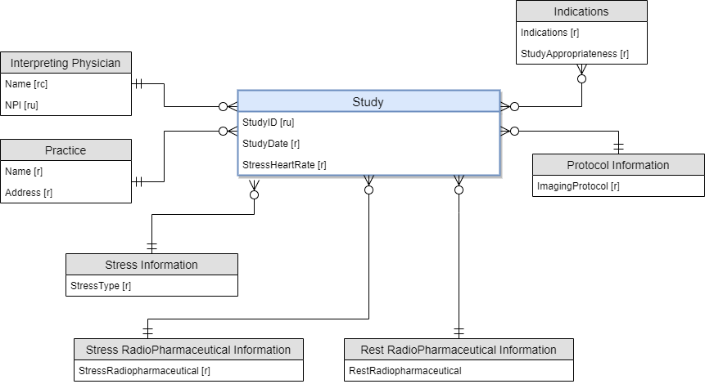

**Normalized Logical Model:**

To create a logical model, the following considerations were made:

**Relations**: For each nuclear stress test, we have one interpreting physician, practice location, radio pharmaceuticals, stress type, and protocol. Therefore, the model indicates a “Many-To-One" relationship between the study entity and these entities. For indications, because this is a “Many-to Many” relationship with the study entity, an intermediate Study-Indications List entity is created.

**Normalization**: The relations in this model are in third normal form as they do not contain any functional or transitive dependencies. There were no functional dependencies that needed to be corrected since each study has a single attribute key (StudyID). All transitive dependencies were removed by creating a new entity with non-prime attributes that are dependent on other non-key attributes.

**Data Types:** The varchar data type is used for most attributes with the exception of StudyDate, the Physician’s National Provider Identifier (NPI), and stress Heart Rate. The data type has been indicated for each attribute in the logical model.

**Required Fields**: The physician information, practice information, indications, and protocol are required fields for a study.

This database’s entities and their relationships are graphically illustrated by this Normalized Logical Model:

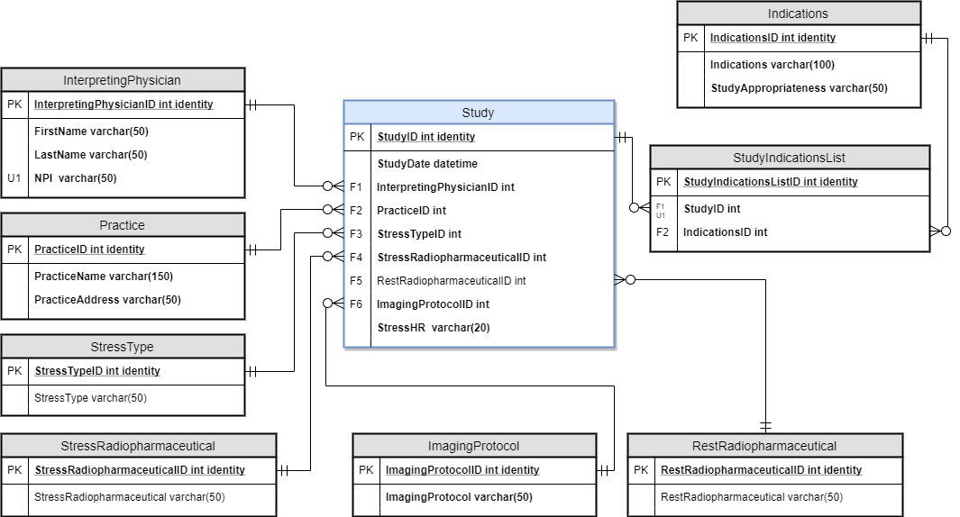

**Part 2**

**Physical Database Design**

--Creating Tables

create table InterpretingPhysician

(

InterpretingPhysicianID int identity,

FirstName varchar(50) not null,

LastName varchar(50) not null,

NPI varchar(50) not null,

constraint pk_InterpretingPhysician primary key (InterpretingPhysicianID),

constraint uk1_InterpretingPhysician unique (NPI)

)

create table Practice

(

PracticeID int identity,

PracticeName varchar (150) not null,

PracticeAddress varchar (100) not null,

constraint pk_Practice primary key (PracticeID)

)

create table StressType

(

StressTypeID int identity,

StressType varchar(50),

constraint pk_StressType primary key (StressTypeID)

)

create table StressRadioPharmaceutical

(

StressRadioPharmaceuticalID int identity,

StressRadioPharmaceutical varchar (50),

constraint pk_StressRadioPharmaceutical primary key (StressRadioPharmaceuticalID)

)

create table ImagingProtocol

(

ImagingProtocolID int identity,

ImagingProtocol varchar(50) not null,

constraint pk_ImagingProtocol primary key (ImagingProtocolID)

)

create table RestRadioPharmaceutical

(

RestRadioPharmaceuticalID int identity,

RestRadioPharmaceutical varchar(50),

constraint pk_RestRadioPharmaceutical primary key (RestRadioPharmaceuticalID)

)

create table Indications

(

IndicationsID int identity,

Indications varchar(100) not null,

StudyAppropriateness varchar(50) not null

constraint pk_Indications primary key (IndicationsID)

)

create table Study

(

StudyID int identity,

StudyDate datetime not null default GetDate(),

InterpretingPhysicianID int not null,

PracticeID int not null,

StressTypeID int not null,

StressRadioPharmaceuticalID int not null,

RestRadioPharmaceuticalID int not null,

ImagingProtocolID int not null,

StressHR varchar(20) not null

constraint pk_StudyID primary key (StudyID),

constraint fk1_InterpretingPhysician foreign key (InterpretingPhysicianID) references InterpretingPhysician(InterpretingPhysicianID),

constraint fk2_Practice foreign key (PracticeID) references Practice(PracticeID),

constraint fk3_StressType foreign key (StressTypeID) references StressType(StressTypeID),

constraint fk4_StressRadioPharmaceutical foreign key (StressRadioPharmaceuticalID) references StressRadioPharmaceutical(StressRadioPharmaceuticalID),

constraint fk5_RestRadioPharmaceutical foreign key (RestRadioPharmaceuticalID) references RestRadioPharmaceutical(RestRadioPharmaceuticalID),

constraint fk6_ImagingProtocol foreign key (ImagingProtocolID) references ImagingProtocol(ImagingProtocolID)

)

create table StudyIndicationsList

(

StudyIndicationsListID int identity,

StudyID int not null,

IndicationsID int not null,

constraint pk_StudyIndications primary key (StudyIndicationsListID),

constraint fk1_Study foreign key (StudyID) references Study(StudyID),

constraint fk2_Indications foreign key (IndicationsID) references Indications(IndicationsID),

constraint uk1_Study unique (StudyID),

constraint uk2_Indications unique (IndicationsID),

)

--Now that tables have been created, we will now insert data.

--Standard language for a nuclear stress test will first be inserted into the database. These include study details for the following fields:

--Stress Information

--Stress Radiopharmaceutical

--Rest Radiopharmaceutical

--Protocol Information

--Indications

insert into StressType(StressType)

values

('Pharmacologic'),

('Excercise')

insert into StressRadioPharmaceutical(StressRadioPharmaceutical)

values

('Tc-99m Sestamibi'),

('Tc-99m Tetrofosmin'),

('Thallium-201')

insert into ImagingProtocol

values

('Rest/Stress 1-day'),

('Rest/Stress 2-day'),

('Stress/Rest 2-day'),

('Stress/Rest 1-day'),

('Stress only')

insert into RestRadioPharmaceutical(RestRadioPharmaceutical)

values

('Tc-99m Sestamibi'),

('Tc-99m Tetrofosmin'),

('Thallium-201')

insert into Indications(Indications, StudyAppropriateness)

values

('Chest Pain', 'Appropriate'),

('Initial detection/risk assessment of CAD', 'Innappropriate'),

('Heart Failure', 'Appropriate'),

('Preoperative evaluation within 30 days preceding low-risk non-cardiac surgery', 'Innappropriate'),

('Dysnepea', 'Appropriate'),

('Arrhythmia', 'Appropriate')

--Hospitals and outpatients and their Physicians are now inserted into the database.

--Note: Physicians can often work for more than one hospital or outpatient center.

insert into InterpretingPhysician(FirstName, LastName, NPI)

values

('John', 'Smith', '1909603422'),

('Emily', 'White', '1884223172'),

('Zach', 'Brown', '1745600234'),

('Dan', 'Snow', '1723123228'),

('Jen', 'Bush', '1312872073')

insert into Practice(PracticeName, PracticeAddress)

values

('ABC Hospital', '321 Street'),

('EFG Hospital', '123 Road'),

('XYZ Hospital', '456 Circle')

--Now that study data language, hospital data, and physician data have been entered into the database, study data can now be submitted

--Insert Study Data

insert into Study

(InterpretingPhysicianID, PracticeID, StressTypeID, StressRadioPharmaceuticalID, ImagingProtocolID, RestRadioPharmaceuticalID, StressHR)

values

('1', '1', '1', '3', '2', '3','94'),

('1', '1', '1', '3', '3', '3','118'),

('1', '1', '1', '3', '3', '3','110'),

('1', '1', '1', '3', '2', '3','92'),

('1', '1', '1', '2', '2', '3','103'),

('2', '2', '1', '1', '2', '3','107'),

('2', '2', '1', '1', '2', '3','103'),

('2', '2', '1', '3', '3', '3','115'),

('2', '2', '1', '3', '3', '2','114'),

('3', '2', '1', '2', '2', '2','93'),

('3', '2', '1', '1', '2', '1','114'),

('3', '2', '1', '1', '3', '1','104'),

('4', '3', '2', '1', '3', '3','92'),

('4', '3', '2', '3', '2', '1','93'),

('4', '3', '1', '3', '1', NULL,'102'),

('4', '3', '1', '2', '1', NULL,'115'),

('4', '3', '2', '2', '1', NULL,'103'),

('4', '3', '1', '3', '4', NULL,'88'),

('4', '3', '1', '3', '4', NULL,'85'),

('4', '3', '2', '1', '4', NULL,'84'),

('4', '3', '1', '1', '4', NULL,'92'),

('4', '3', '1', '1', '5', NULL,'93'),

('4', '3', '1', '2', '5', NULL,'115'),

('5', '3', '2', '2', '5', NULL,'114'),

('5', '3', '1', '2', '5', NULL,'90'),

('5', '3', '2', '1', '5', NULL,'90'),

('5', '3', '2', '2', '5', NULL,'90'),

('5', '3', '2', '1', '3', '1','90'),

('5', '3', '2', '2', '1', NULL,'90'),

('5', '3', '2', '2', '4', NULL,'112')

--Insert Study Indications Data

insert into StudyIndicationsList(StudyID, IndicationsID)

values

('1','2'),('2','4'),('3','4'),('4','2'),('5','6'),('6','1'),('7','4'),('8','4'),('9','5'),('10','4'),('11','2'),('12','5'),('13','2'),('14','5'),('15','3'),('16','3'),('17','1'),('18','6'),('19','1'),('20','1'),('21','1'),('22','1'),('23','4'),('24','4'),('25','3'),('26','3'),('27','6'),('28','6'),('29','6'),('30','1')

--We can now create a view to see a summary of submitted studies to the registry

go

create view StudyListSummary

as

select

StudyID,

StudyDate,

StressHR,

InterpretingPhysician.FirstName,

InterpretingPhysician.LastName,

InterpretingPhysician.NPI,

Practice.PracticeName,

StressType.StressType,

StressRadioPharmaceutical.StressRadioPharmaceutical,

RestRadioPharmaceutical.RestRadioPharmaceutical,

ImagingProtocol.ImagingProtocol

from Study

join InterpretingPhysician on Study.InterpretingPhysicianID = InterpretingPhysician.InterpretingPhysicianID

join Practice on Study.PracticeID = Practice.PracticeID

join StressType on Study.StressTypeID = StressType.StressTypeID

join StressRadioPharmaceutical on Study.StressRadioPharmaceuticalID = StressRadioPharmaceutical.StressRadioPharmaceuticalID

join ImagingProtocol on Study.ImagingProtocolID = ImagingProtocol.ImagingProtocolID

left join RestRadioPharmaceutical on Study.RestRadioPharmaceuticalID = RestRadioPharmaceutical.RestRadioPharmaceuticalID

go

select * from StudyListSummary

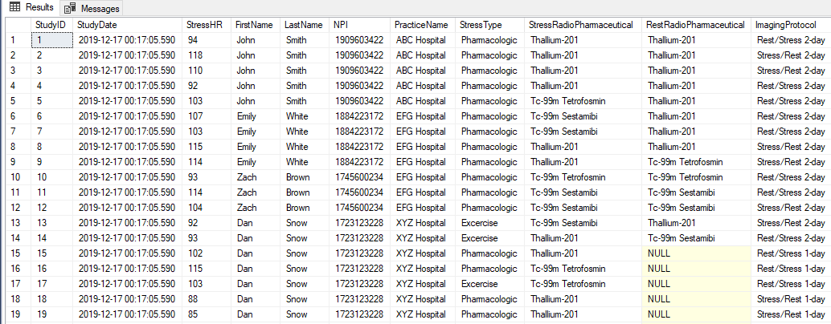

--We can also now answer some Data-related questions for the purposes of Quality Improvement in Nuclear Cardiology

--Data Question: What is the total number of studies performed by Dr. John Smith that contain the following attributes:

--Pharmacologic Stress Type

--Thallium Radiopharmaceutical

--2-day protocol

--Note: clinical guidelines currently recommend that nuclear cardiology procedures are practiced WITHOUT any of these attributes

select

count(case when NPI = '1909603422' then 1 end) as TotalStudies,

count(case when NPI = '1909603422' and StressType = 'Pharmacologic' then 1 end) as PharmacologicCount,

count(case when NPI = '1909603422' and StressRadioPharmaceutical = 'Thallium-201' then 1 end) as StressThalliumCount,

count(case when NPI = '1909603422' and RestRadioPharmaceutical = 'Thallium-201' then 1 end) as RestThalliumCount,

count(case when (ImagingProtocol = 'Rest/Stress 2-day' or ImagingProtocol = 'Stress/Rest 2-day') and NPI = '1909603422' then 1 end) as TwoDayProtocolCount

from StudyListSummary



--Nearly all of Dr. Smith’s studies are not in compliance with current guidelines. He needs help!

--Data Question: Which Studies are Appropriate and Inappropriate? And which hospitals and physicians are they attributed to?

--Note: It is recommended that hospitals and outpatient centers reduce the number of inappropriate studies

go

create view StudyAppropriatenessSummary

as

select

Study.StudyID,

Practice.PracticeName,

InterpretingPhysician.NPI,

InterpretingPhysician.FirstName,

InterpretingPhysician.LastName,

Indications.StudyAppropriateness

from StudyIndicationsList

join Indications on StudyIndicationsList.IndicationsID = Indications.IndicationsID

join Study on StudyIndicationsList.StudyID = Study.StudyID

join Practice on Study.PracticeID = Practice.PracticeID

left join InterpretingPhysician on Study.InterpretingPhysicianID = InterpretingPhysician.InterpretingPhysicianID

go

select * from StudyAppropriatenessSummary

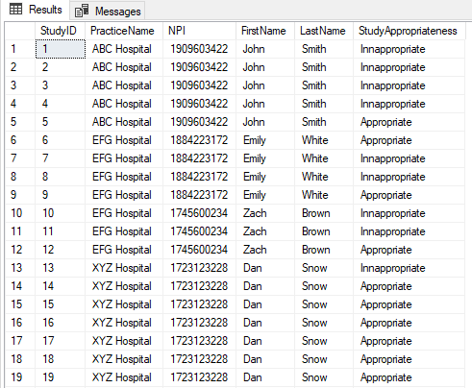

--Data Question: Which Studies are Exercise vs Pharmacologic? And which hospitals and physicians are they attributed to?

--Note: It is recommended that hospitals and outpatient centers minimize pharmacologic studies as these are more harmful to patients due to high radiation

go

create view StressTypeSummary

as

select

StudyID,

InterpretingPhysician.FirstName,

InterpretingPhysician.LastName,

InterpretingPhysician.NPI,

Practice.PracticeName,

StressType.StressType

from Study

join StressType on Study.StressTypeID = StressType.StressTypeID

join InterpretingPhysician on Study.InterpretingPhysicianID = InterpretingPhysician.InterpretingPhysicianID

join Practice on Study.PracticeID = Practice.PracticeID

go

select * from StressTypeSummary

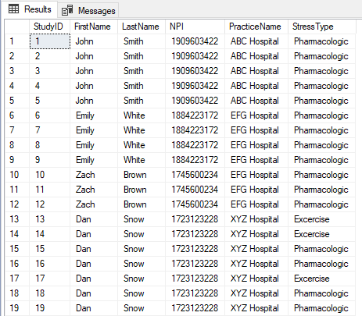

--Data Question: Which Studies are 1 Day vs. 2 Day? And which hospitals and physicians are they attributed to?

--Note: It is recommended that hospitals and outpatient centers minimize the use of a 2-day protocol as these are more harmful to patients due to high radiation

go

create view ImagingProtocolSummary

as

select

StudyID,

InterpretingPhysician.FirstName,

InterpretingPhysician.LastName,

InterpretingPhysician.NPI,

Practice.PracticeName,

ImagingProtocol.ImagingProtocol

from Study

join ImagingProtocol on Study.ImagingProtocolID = ImagingProtocol.ImagingProtocolID

join InterpretingPhysician on Study.InterpretingPhysicianID = InterpretingPhysician.InterpretingPhysicianID

join Practice on Study.PracticeID = Practice.PracticeID

go

select * from ImagingProtocolSummary

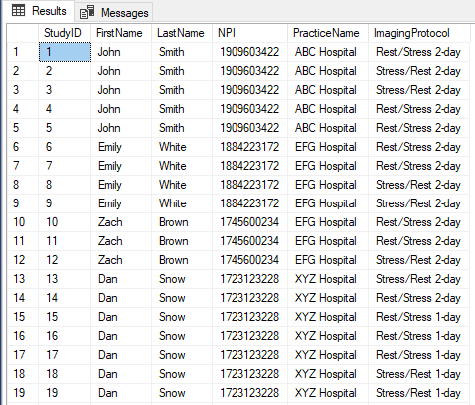

--It is sometimes necessary to make updates where data errors exist

--For example, if a nuclear stress test is missing a RestRadiopharmaceutical, the protocol must be "Stress Only" because there is no rest portion of the test

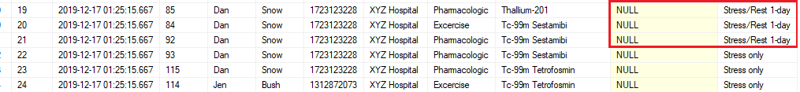

--If the protocol is not “Stress Only,” it is an error in the hospital’s reporting. The database can be updated accordingly

update Study

set ImagingProtocolID = '5'

where RestRadioPharmaceuticalID is null

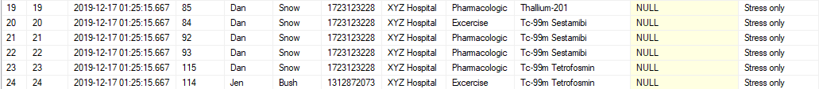

--Because this is likely an ongoing issue with data errors that will happen in the future, this can easily be converted to a stored procedure

go

create procedure FixProtocolErrors

as

begin

update Study

set ImagingProtocolID = '5'

where RestRadioPharmaceuticalID is null

end

go

--Very similar update queries can be performed when hospital name and address change

#R can be used for further analysis of this database

#Begin creating connection to SQL Server using 64-bit DSN

require(RODBC)

myconn <- odbcConnect("Project1")

sqlSelectStatement <-

"select

StudyID,

StudyDate,

StressHR,

InterpretingPhysician.FirstName,

InterpretingPhysician.LastName,

InterpretingPhysician.NPI,

Practice.PracticeName,

StressType.StressType,

StressRadioPharmaceutical.StressRadioPharmaceutical,

RestRadioPharmaceutical.RestRadioPharmaceutical,

ImagingProtocol.ImagingProtocol

from Study

join InterpretingPhysician on Study.InterpretingPhysicianID = InterpretingPhysician.InterpretingPhysicianID

join Practice on Study.PracticeID = Practice.PracticeID

join StressType on Study.StressTypeID = StressType.StressTypeID

join StressRadioPharmaceutical on Study.StressRadioPharmaceuticalID = StressRadioPharmaceutical.StressRadioPharmaceuticalID

join ImagingProtocol on Study.ImagingProtocolID = ImagingProtocol.ImagingProtocolID

left join RestRadioPharmaceutical on Study.RestRadioPharmaceuticalID = RestRadioPharmaceutical.RestRadioPharmaceuticalID"

sqlResult <- sqlQuery(myconn, sqlSelectStatement)

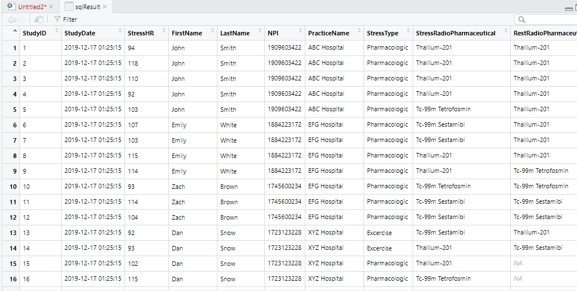

#The data can be viewed on R like the views created on SQL

#We can now graph some of our data on R to answer some data questions

#Data Question: What is the most common study protocol in the database?

ProtocolCount <-table(sqlResult$ImagingProtocol)

barplot(ProtocolCount,

main="Frequency of Studies by Protocol in Database")

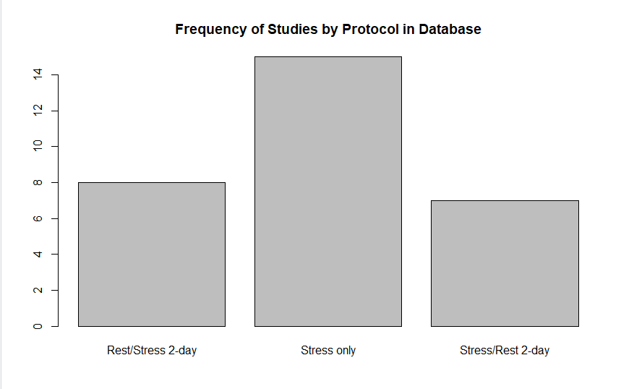

#Data Question: What are the most commonly recorded Stress Heart Rate (StressHR) in the database?

hist(sqlResult$StressHR,

main="Frequency of Studies by StressHR",

xlab="StressHR")

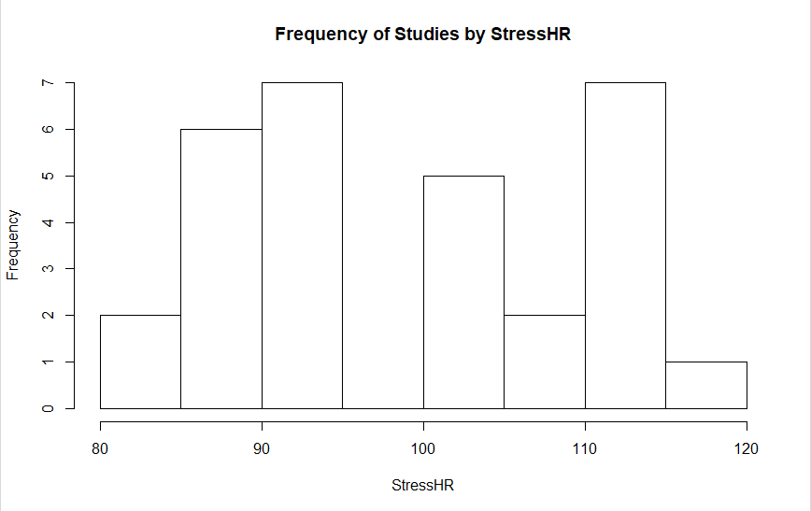

**Summary**

As I worked on this project, the issue of variability and data standardization become clearer. Since every hospital and outpatient center in the country are completing their medical report using different terminology, fields, and templates, the collection and combining of these reports will likely cause issues in long run as there will be mismatches and inconsistencies. Consequently, the analysis of this data will prove difficult. For example, Hospital A may record their protocol as “One-Day Stress/Rest” while Hospital B may record “1-Day, S/R.” This data standardization issue may be remedied by stored Update procedures to provide some consistency. However, the onus is ultimately on the leaders of the medical field to provide education on standard medical reporting and to ensure that all practitioners are staying up to date on how reports should be completed.

Overall, the collection of medical data to store and analyze in a database using tools like SQL and R will be critical to the quality improvement of medicine. In this project, it was demonstrated how nuclear stress reports can be collected and organized in a SQL database. It was then demonstrated how queries can be run to ask questions about the data including the count of appropriate vs. inappropriate indications, study protocols, and types of radiopharmaceuticals. Finally, R was used to demonstrate how graphical tools can be used to visualize the data. Answers to data questions like these will provide a monumental role in understanding how medicine is being practiced today and what areas we need to improve upon.